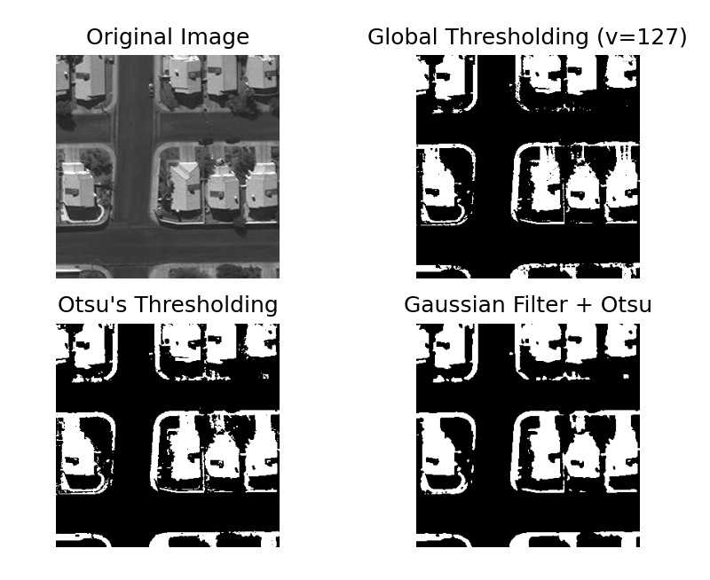

**Otsu segmented image**

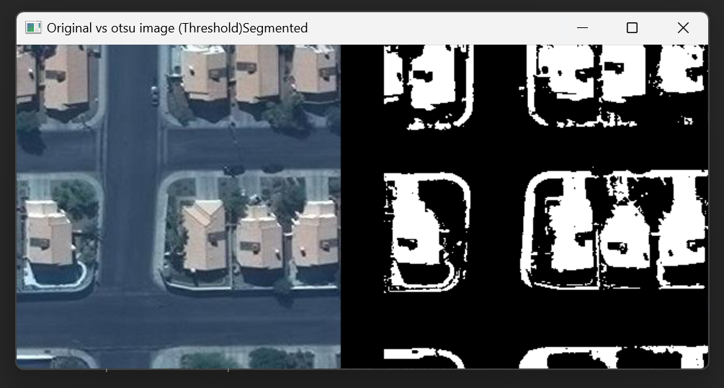

**Initial output from Mak image**

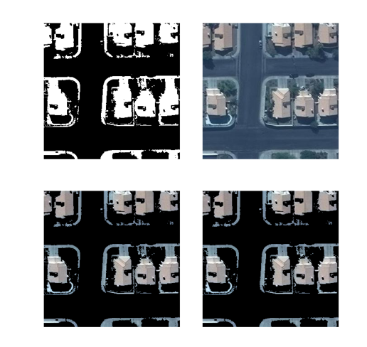

**Using HSV Color Segmentation :**

In terms of doing in the RGB Color Channel dimension, we use HSV or Hue, Saturation, and Value Space

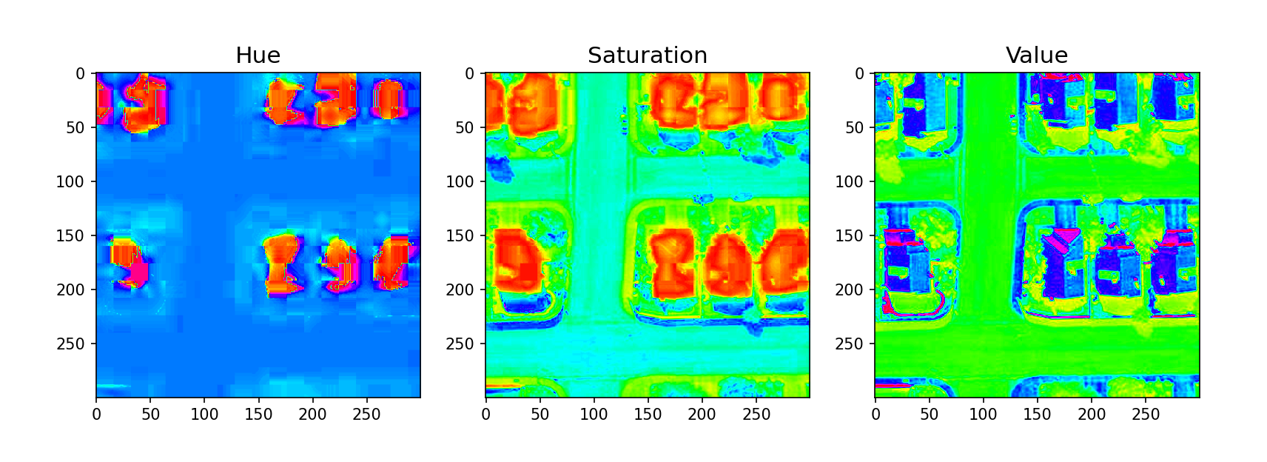

**Using Saturated Image as Mask and implementing Otsu segmentation:**

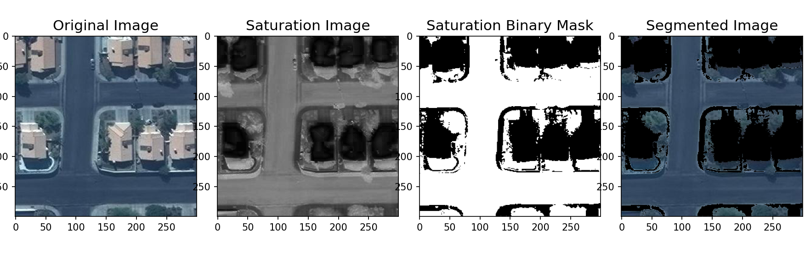

**Comparing original image with saturated image got from HSV color segm :**

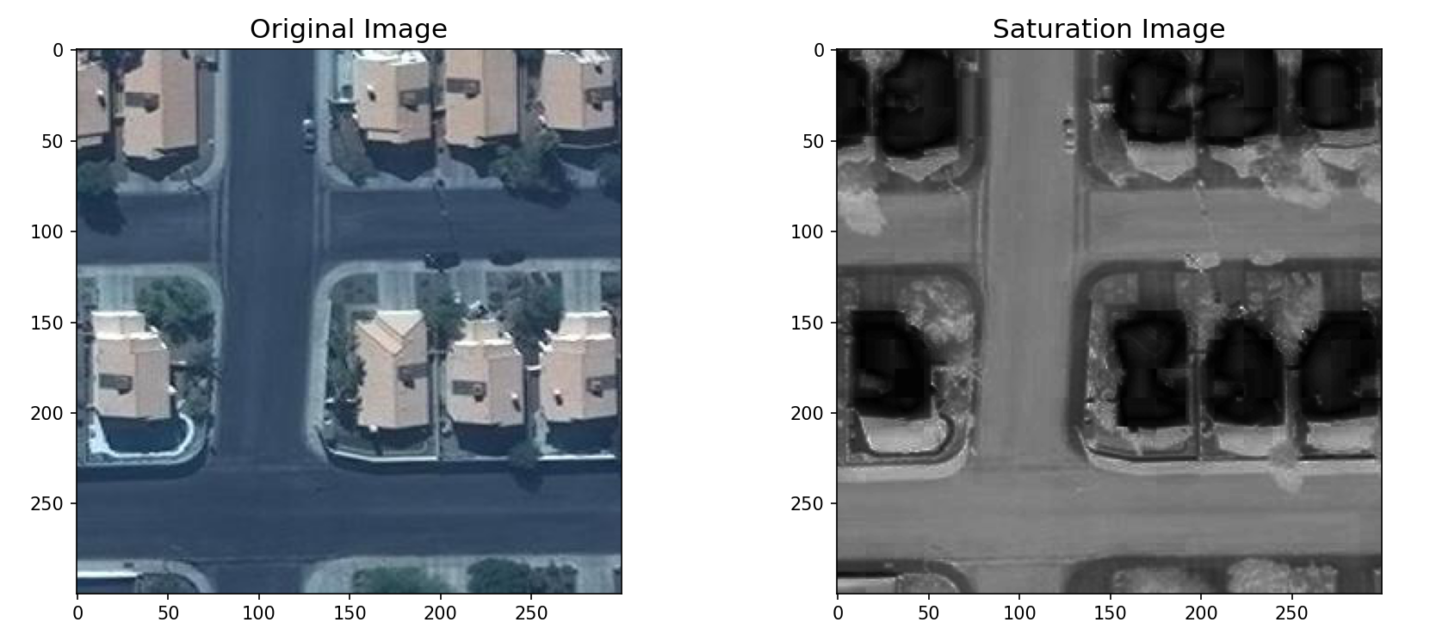

**Converting the saturated image into binary image using respective threshould values (val=40):**

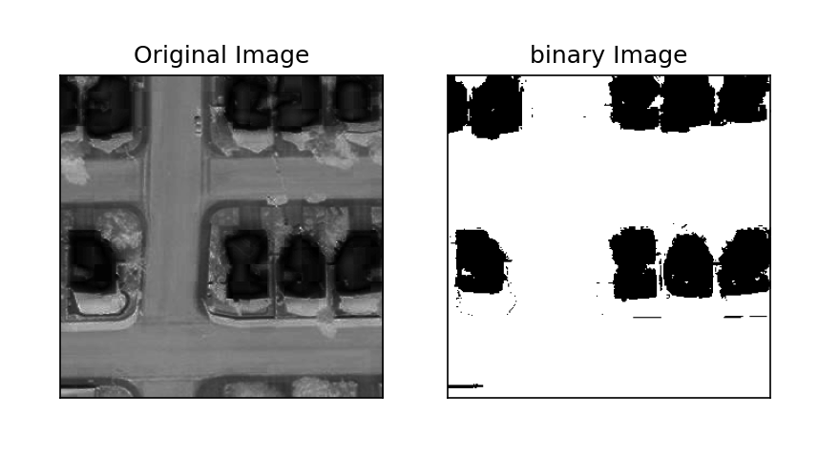

**Using the binary image as our mask and removing roads from original image :**

Process : By considering the white regions as 0 and multiplying with original color image

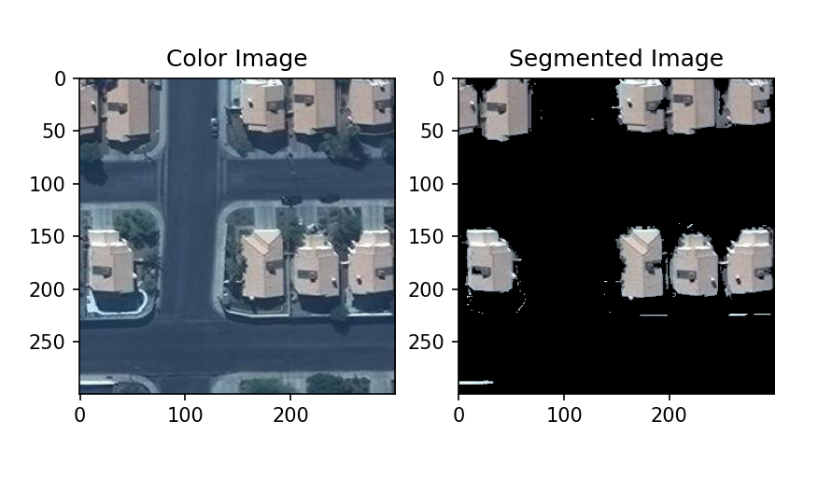

**Segmented image output :**

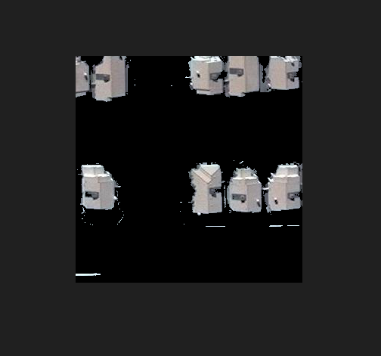

**Multi otsu Image segementation:**

